Course Title: Social Immersive Learning
Course Code: 24UC0021
Name: L.Ishitha
Roll No: 2420030041
Section: 10

Title of the Event:
AI Tools and Trends: Replit

Organized by:
Department of Computer Science and Engineering (AIML), KLH University – Bachupally Campus

Date:
October 21, 2025 | 10:00 AM – 3:30 PM

Introduction:
The AI Tools and Trends: Replit event was organized to introduce participants to the rapidly evolving landscape of Artificial Intelligence in software development. The session focused on the integration of AI-powered development tools, specifically emphasizing Replit, an innovative cloud-based coding platform. The event showcased how AI is transforming modern programming practices by simplifying development, enhancing collaboration, and enabling creativity. It aimed to motivate students, developers, and technology enthusiasts to embrace AI tools to build efficient, intelligent, and scalable digital solutions.

About the Event:
The event offered a comprehensive, hands-on learning experience with Replit’s AI features, including its intelligent coding assistant, Ghostwriter. Participants explored how Replit leverages artificial intelligence to automate coding tasks, suggest solutions, and enhance developer productivity. Workshops, live demonstrations, and project showcases illustrated how AI-driven development platforms are reshaping the future of programming.
Students also engaged in collaborative activities that encouraged innovation, teamwork, and problem-solving using AI-assisted tools. The event served as a bridge between traditional programming methods and next-generation AI-integrated development environments, preparing participants to adapt to the technological shifts in the software industry.

Key Highlights:
- Introduction to Replit’s AI coding assistant – Ghostwriter.
- Hands-on workshops demonstrating AI-based code completion and debugging.
- Live project showcases on AI-integrated development workflows.
- Insights into how AI enhances efficiency and creativity in programming.
- Interactive discussions with mentors on the future of AI in software development.

My Participation:
I actively participated in the AI Tools and Trends: Replit event, attending both the technical workshop and live demo sessions. I learned how Replit’s AI features assist developers in writing optimized code, understanding algorithms, and debugging efficiently. The event deepened my understanding of how artificial intelligence can enhance productivity and creativity in coding. I also gained practical exposure to using AI tools for collaborative development and realized the importance of keeping up with emerging trends in software engineering.

Event Photographs:
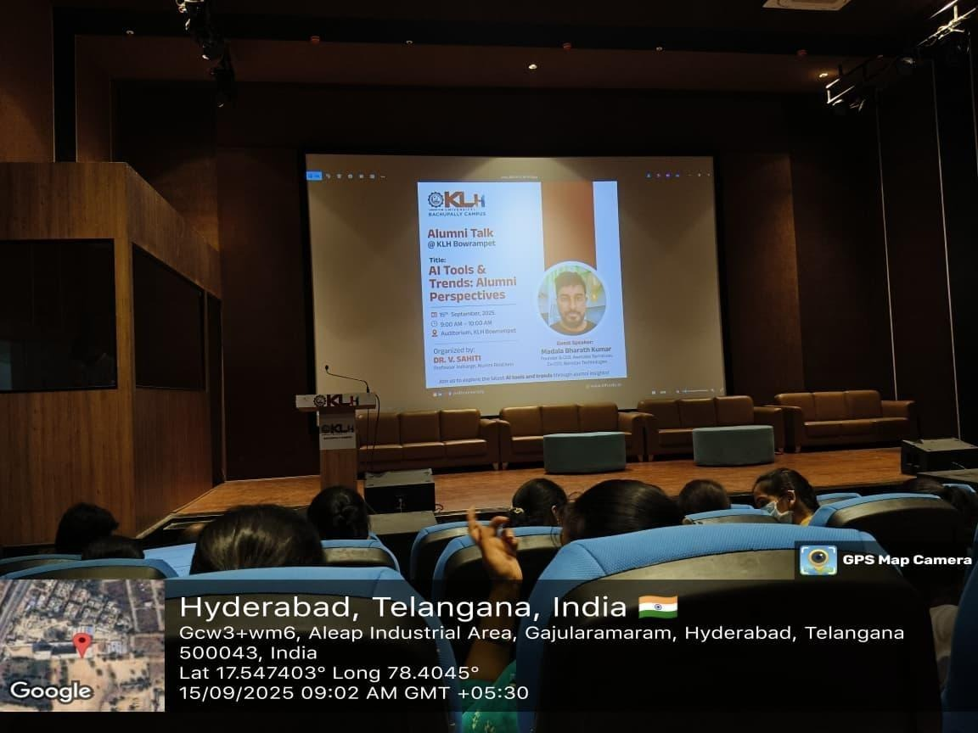

Conclusion:
The AI Tools and Trends: Replit event was an eye-opening experience that highlighted the impact of AI on the future of software development. It provided valuable knowledge about AI-driven tools, encouraging me to incorporate such technologies in my learning process. The event inspired me to explore intelligent coding platforms further and to innovate by leveraging the power of AI in building real-world applications.

Acknowledgment:
Special thanks to KLH University and the Department of Computer Science and Engineering (AIML) for organizing this informative event. Their efforts in introducing students to the latest AI advancements have been instrumental in shaping our understanding of modern software development trends.

